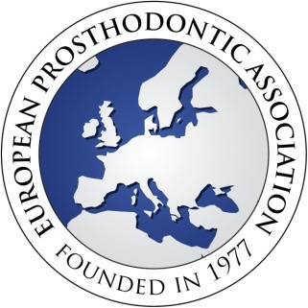

Title: Choose an item. Surname / Family name:
First name(s):
Dental / Specialist Qualifications (degrees / diplomas):
Address for correspondence:
City Postcode: Country:
Telephone number:
Email (essential) :
I wish to apply for membership of the European Prosthodontic Association. I am a member of my
National Prosthodontic Association which is:
(If not a member of a prosthodontic association, please include a brief Curriculum Vita that indicates your special interest in Prosthodontics.)
I agree to my name and email address being placed on the EPA members web page.
I consent to be contacted via mail or electronic methods.
Signature: Please sign here, print name or place an electronic signature

Membership options | Membership fees
Membership of the EPA + subscription to the on-line version of the European Journal of Prosthodontics and Restorative Dentistry (4 issues yearly) | 80 Euros

Please pay the membership fee (see below for payment method) and email this form to epadental.acc@gmail.com

Payment method | Payment to | Tick one
Bank Transfer | Beneficiary name: European Prosthodontic Association  IBAN : GR4501727940005794103275177  SWIFT_BIC : PIRBGRAA
Paypal | epadental.acc@gmail.com

